30,000-Gallon Storage Vessel
Rocky Mount, NC

VESSEL SPECIFICATIONS

Manufacturer | Year | Capacity | PSI | Serial Number / National Board Number
Atlas | 1968 | 30,000 | 250 | ST-653/ NA

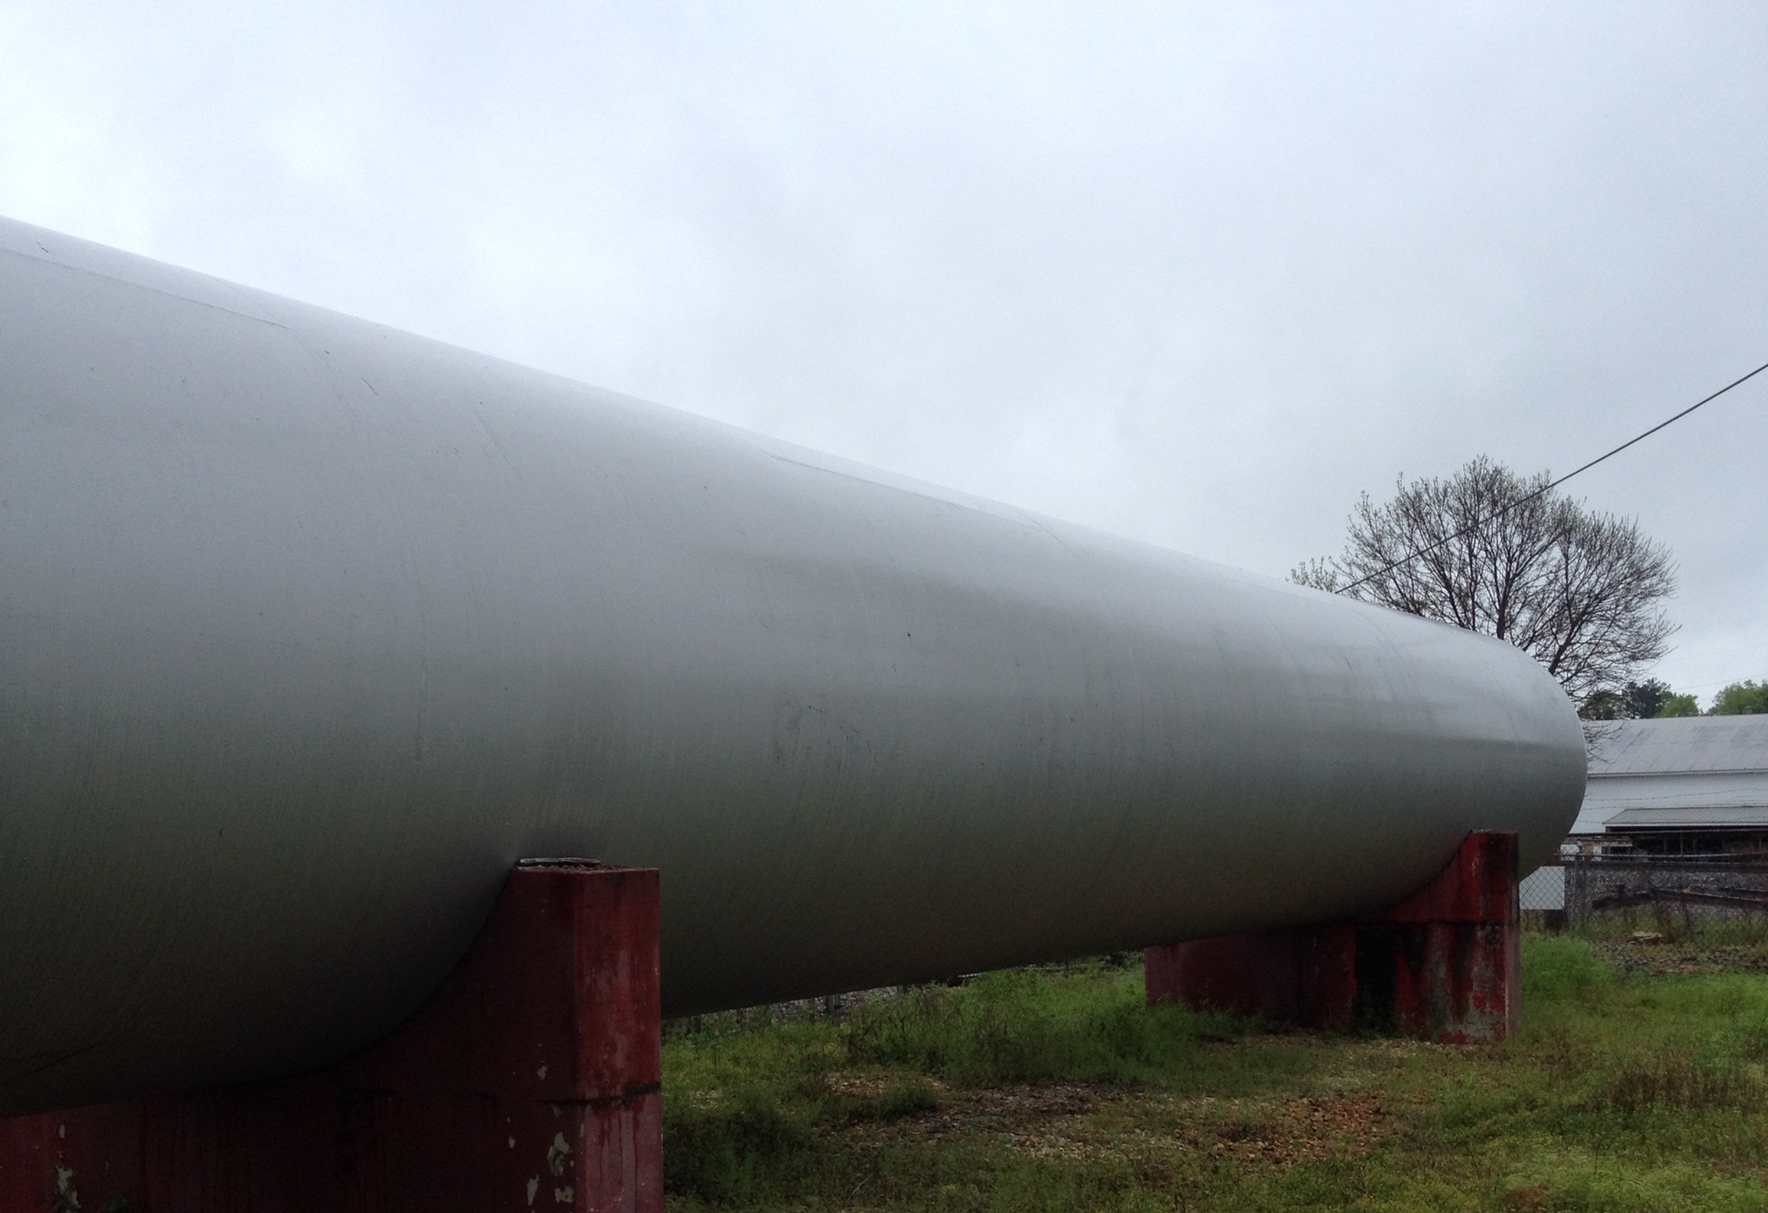
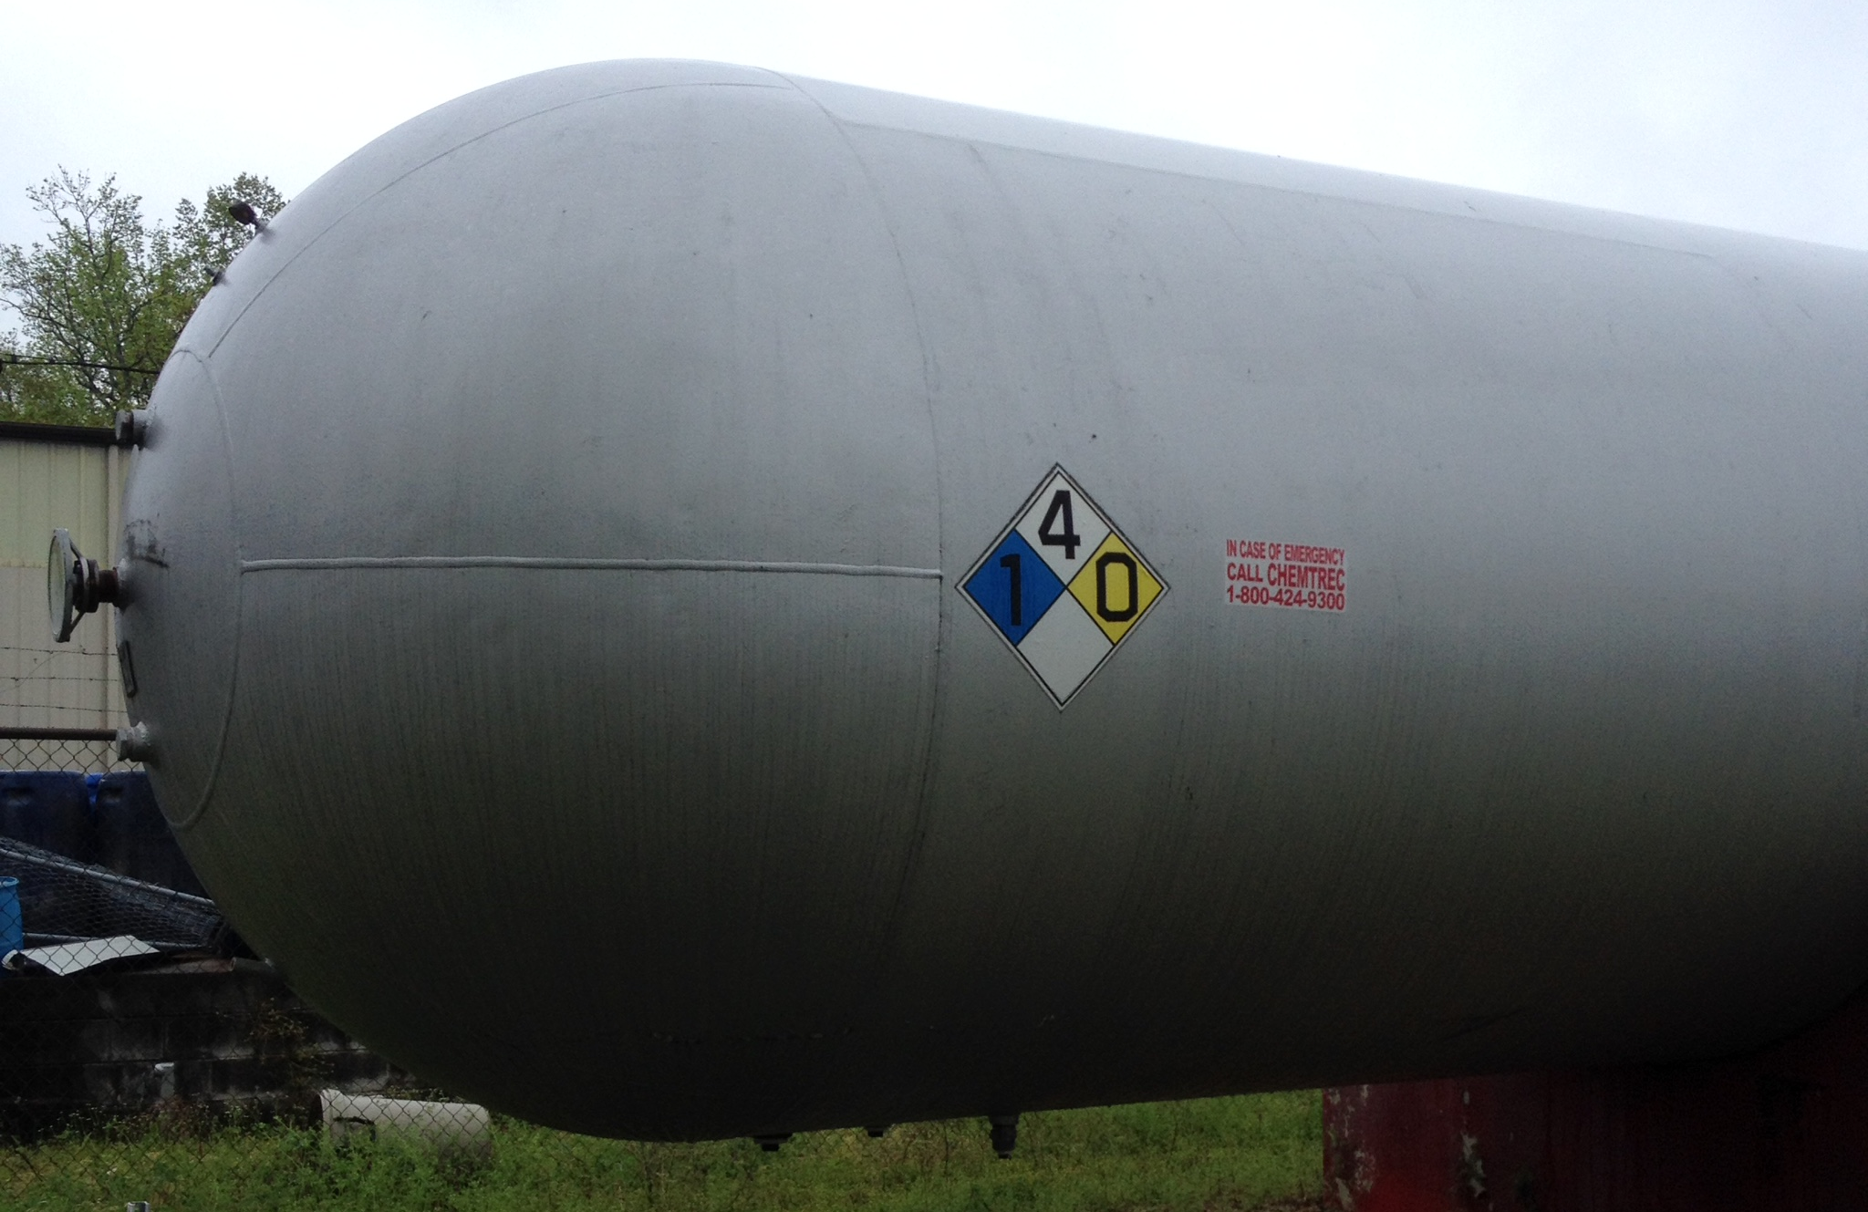
The vessel listed is ASME certified and was manufactured by Atlas. This steel vessel is 104-inches in diameter and 72-foot in length. The hemispherical heads are .420” thick and the shell is .750” thick.

