

**30,000-Gallon Storage Vessel**

**Rocky Mount, NC**

**VESSEL SPECIFICATIONS**

|  |  |  |  |  |
| --- | --- | --- | --- | --- |
| **Manufacturer** | **Year** | **Capacity** | **PSI** | **Serial Number/ National Board Number** |
| RD Cole | 1957 | 30,000 | 250 | 8602/ 1369 |

The vessel listed is ASME certified and was manufactured by R.D. Cole. It has a National Board number with a U-1A data sheet. Its shell sections and hemispherical heads are constructed of SA-212 steel. The vessel is 63-foot 6-inches in length and 9-foot 3-inches in diameter.

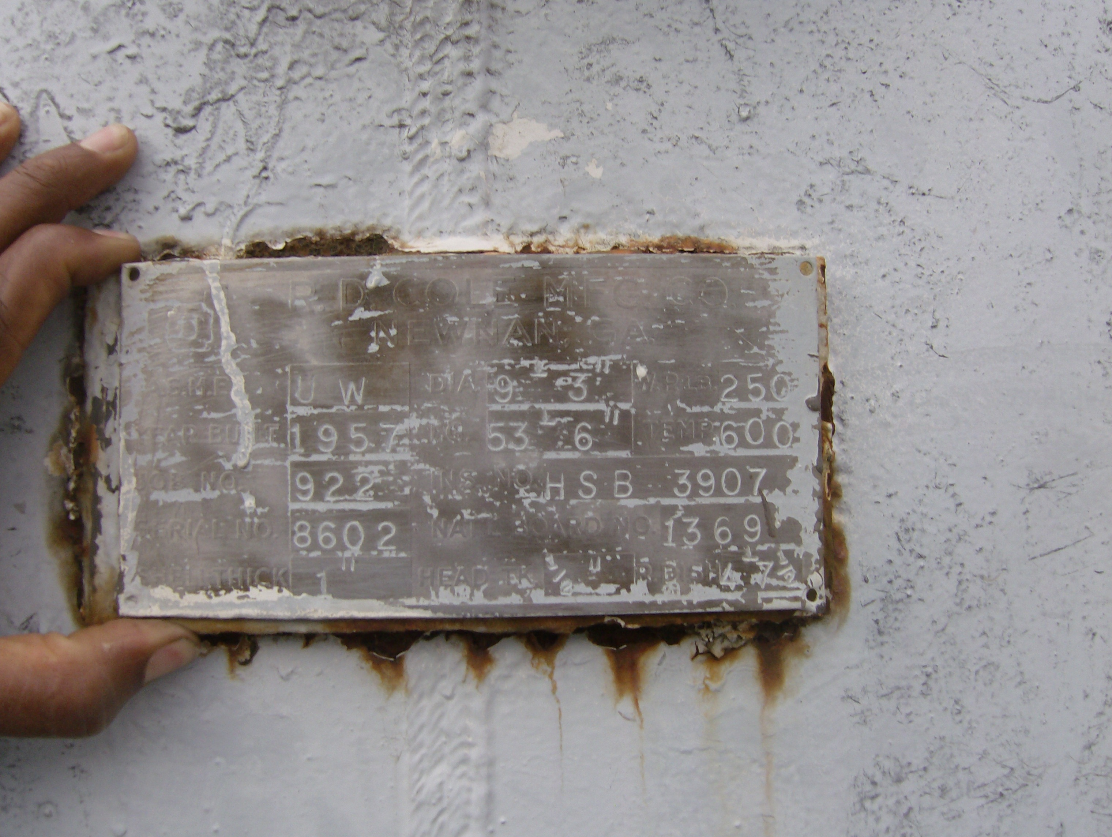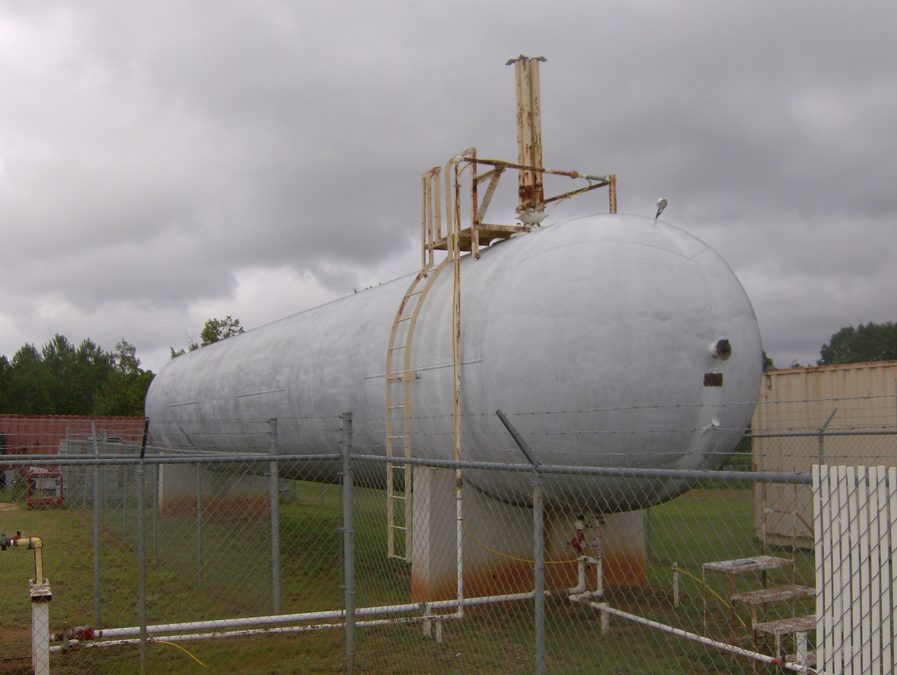

Macintosh HD:Users:jessicaveldman:Desktop:R D COLE NB# 1369 (1).pdf