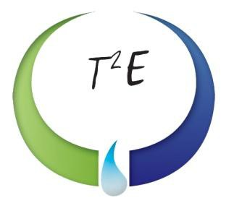

30,000-Gallon Storage Vessel
Rocky Mount, NC

VESSEL SPECIFICATIONS

Manufacturer | Year | Capacity | PSI | Serial Number / National Board Number
Unknown | 1955 | 30,000 | 250 | 414/ NA

The vessel listed is ASME certified. This steel vessel is 110-inches inner diameter with hemispherical heads.
