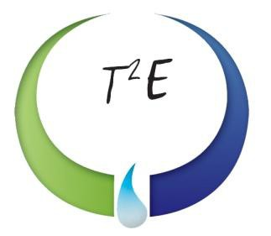


30,000-Gallon Storage Vessel
Rocky Mount, NC

VESSEL SPECIFICATIONS

Manufacturer | Year | Capacity  (Liquid Gallons) | PSI | Serial Number/ National Board Number
Unknown | Unknown | 30,000 | Unknown | Temp00022/ NA

This is a steel vessel with elliptical heads.

