

**30,000-Gallon Storage Vessel**

**Rocky Mount, NC**

**VESSEL SPECIFICATIONS**

|  |  |  |  |  |
| --- | --- | --- | --- | --- |
| **Manufacturer** | **Year** | **Capacity** | **PSI** | **Serial Number/ National Board Number** |
| Delta | 1958 | 30,000 | 250 | 241271 / 28829 |

The vessel listed is ASME certified and was manufactured by Delta Tank Manufacturing Company Inc. This steel vessel is 142” in diameter and 41.5-foot in length with hemispherical heads. The heads are .565” thick and the shell is 1.0625” thick.

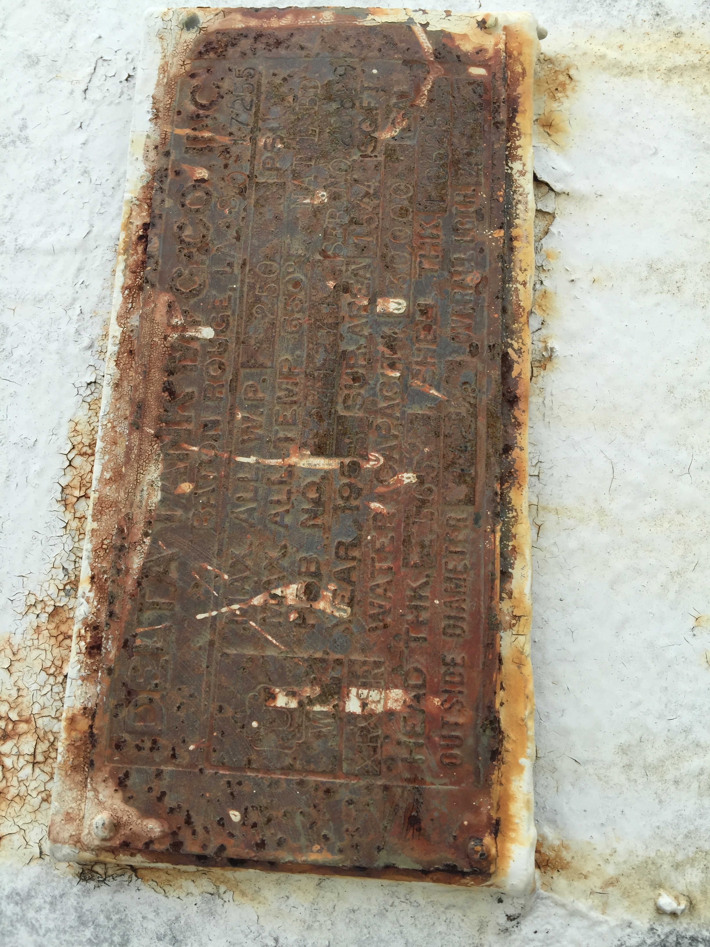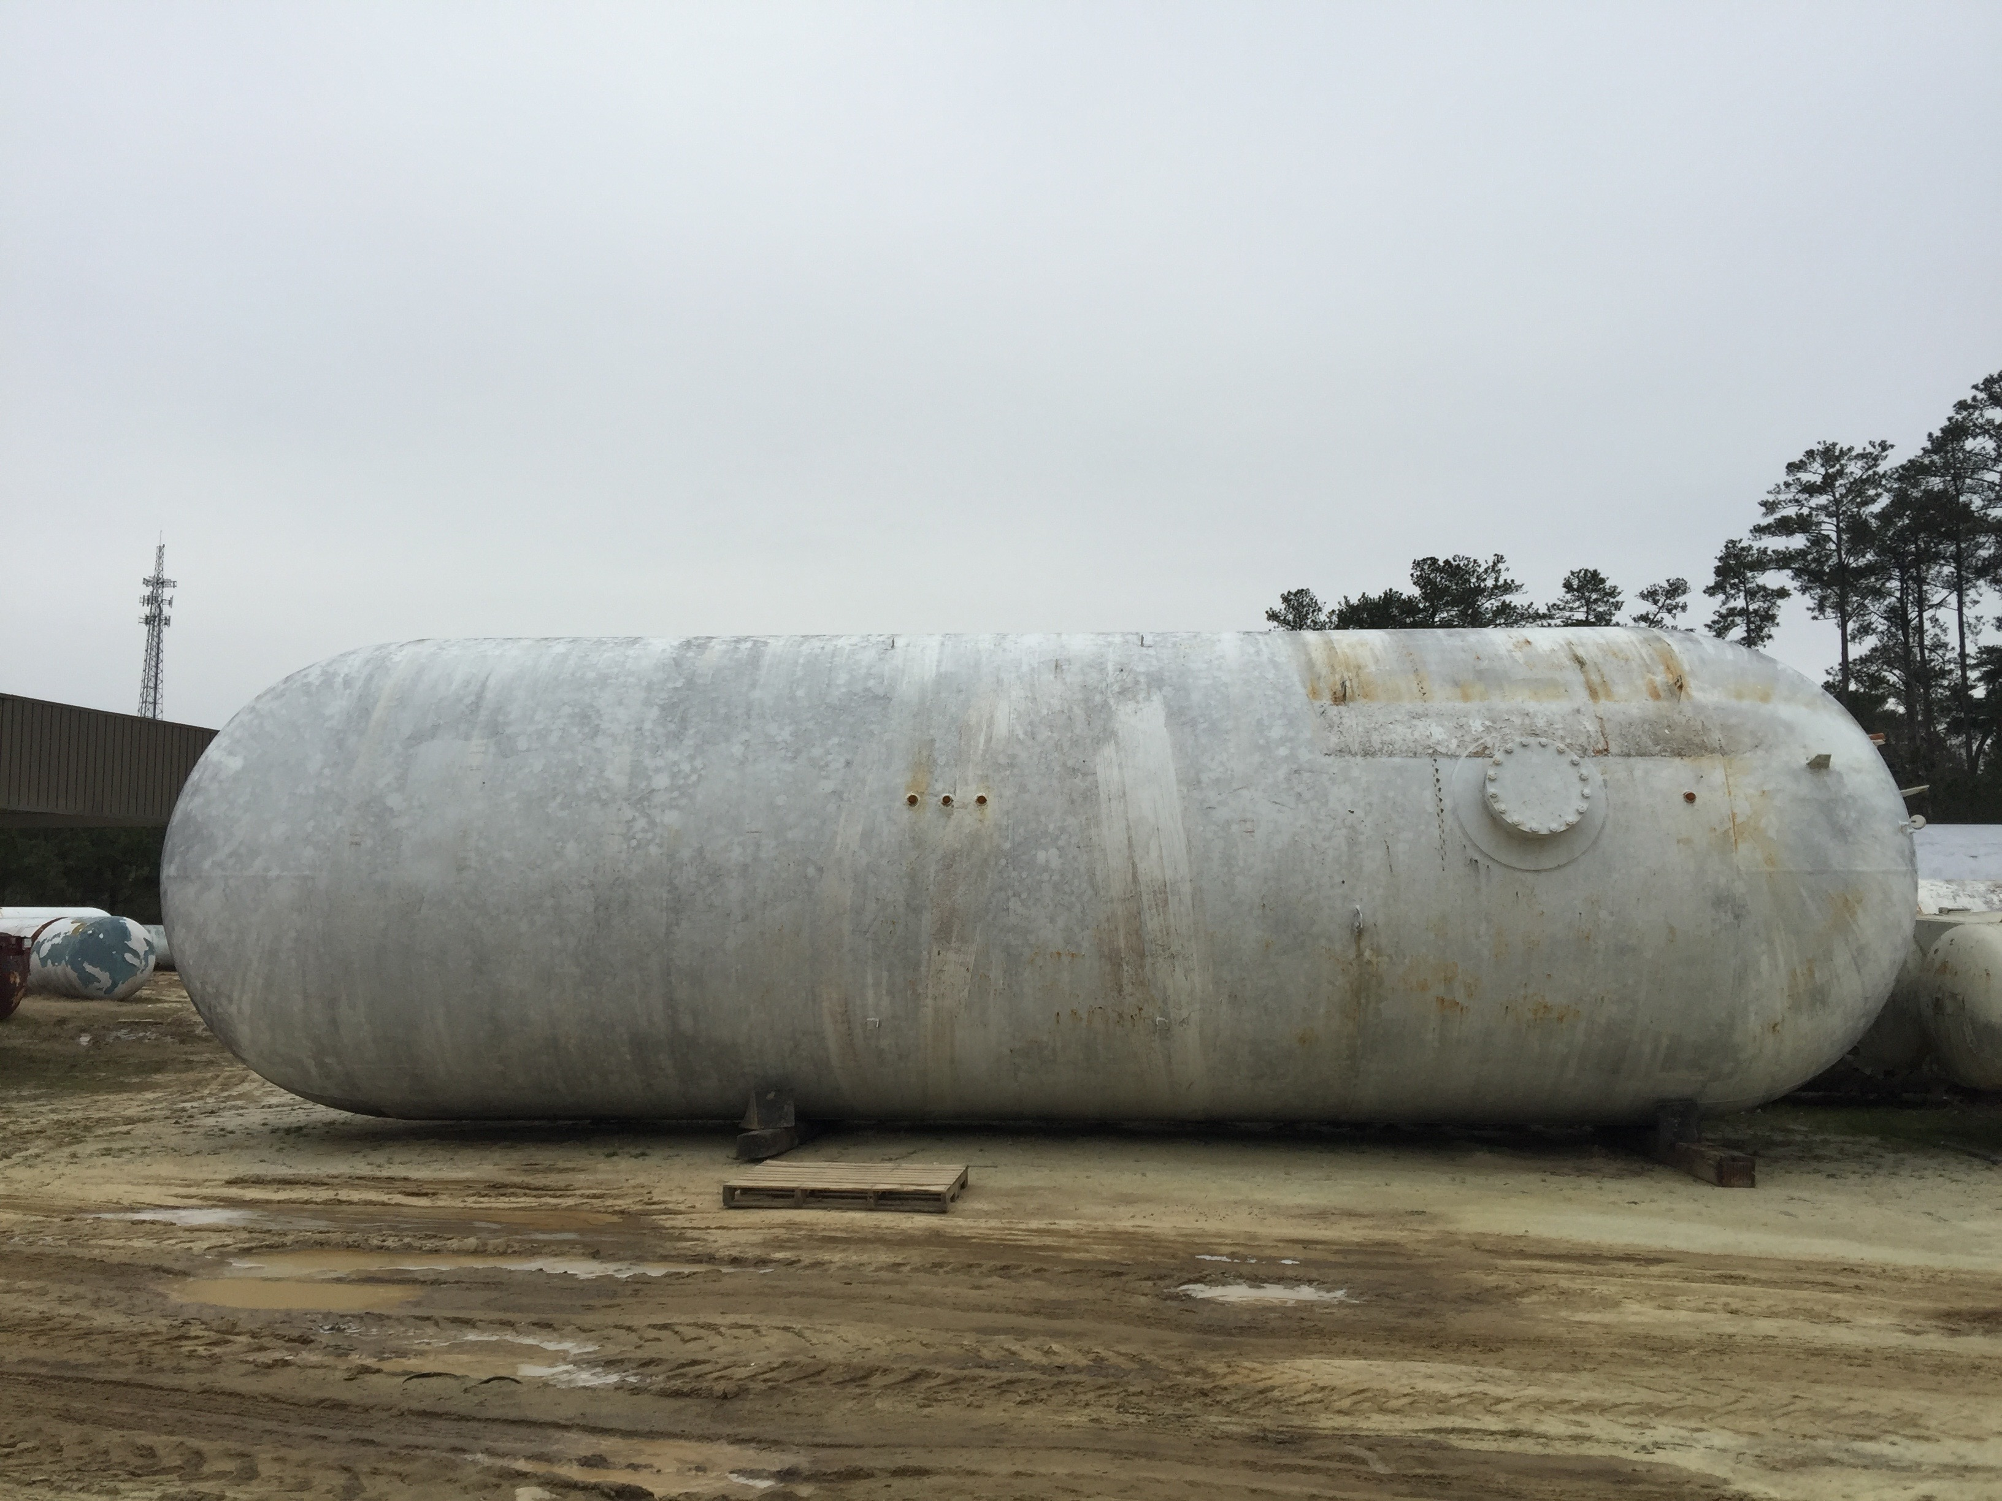

Macintosh HD:Users:jessicaveldman:Desktop:DELTA TANK MFG NB 28829.pdf