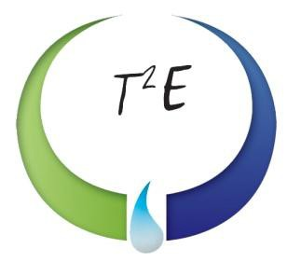

30,000-Gallon Storage Vessel
Rocky Mount, NC

VESSEL SPECIFICATIONS

Manufacturer | Year | Capacity | PSI | Serial Number / National Board Number
Sun Ship | 1946 | 30,000 | Unknown | Temp00009/ NA

The vessel listed is ASME certified and was manufactured by Sun Shipbuilding. This is a steel vessel with elliptical heads.

