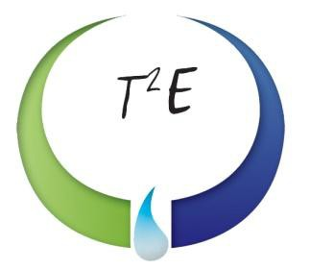

30,000-Gallon Storage Vessel
Rocky Mount, NC

VESSEL SPECIFICATIONS

Manufacturer | Year | Capacity | PSI | Serial Number/ National Board Number
ACF | Unknown | 30,000 | Unknown | 34-0578#1/ NA

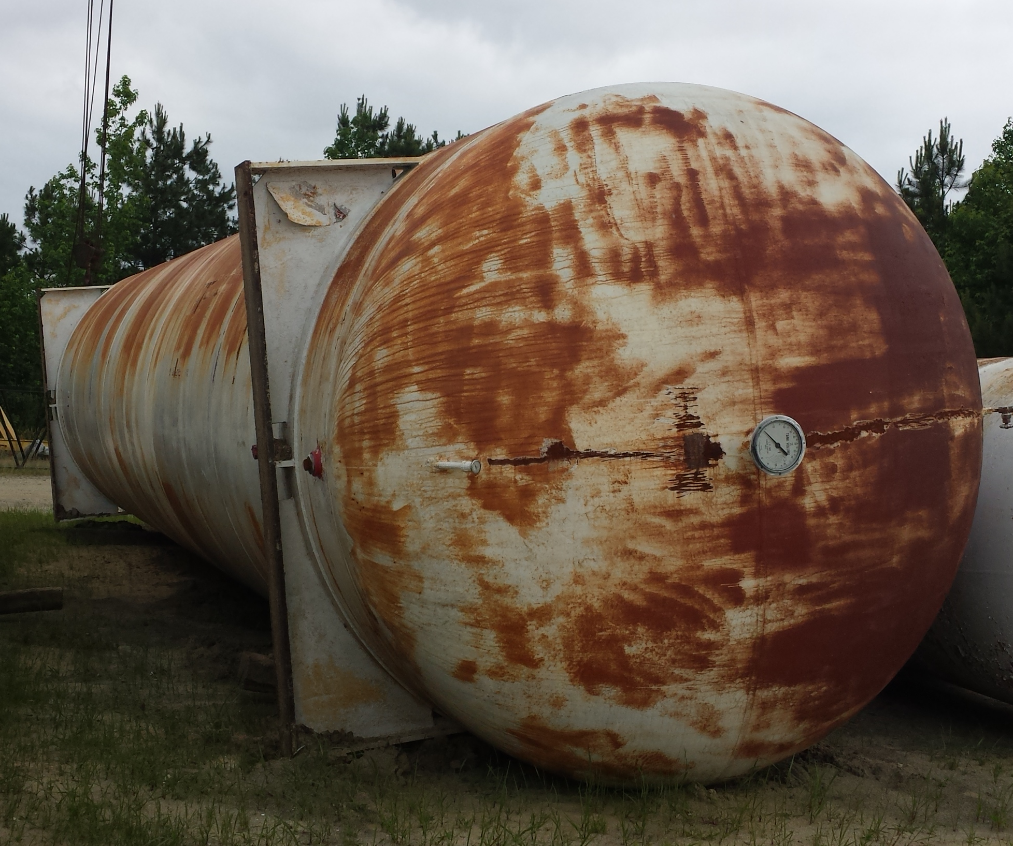
The vessel listed is ASME certified and was manufactured by ACF. It has welded steel saddles and elliptical heads.

