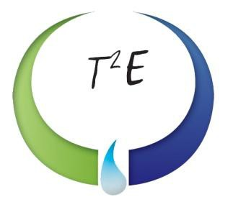

30,000-Gallon Storage Vessel
Rocky Mount, NC

VESSEL SPECIFICATIONS

Manufacturer | Year | Capacity | PSI | Serial Number / National Board Number
Trinity | 1975 | 30,000 UG | 250 | 607486/ 76149

The vessel listed is ASME certified and was manufactured by Trinity Industries, Inc. This Underground steel vessel is 109-inches in diameter and 66-foot in length. Its shell thickness is ..6733” and the hemispherical heads are .4375” thick.
