

**30,000-Gallon Storage Vessel**

**Sikeston, MO**

**VESSEL SPECIFICATIONS**

|  |  |  |  |  |
| --- | --- | --- | --- | --- |
| **Manufacturer** | **Year** | **Capacity**  **(Liquid Gallons)** | **PSI**  **(@ 125 °F max.)** | **Serial Number/ National Board Number** |
| Riley- Beaird | 1987 | 30,000 | 250 | 123446-01-1 / 55237 |

The vessel listed is ASME certified and was manufactured by Riley- Beaird, Inc. It has a National Board number with a U-1A data sheet. Its shell sections and hemispherical heads are constructed of SA-612 steel. The vessel is 66-foot in length and 9-foot in diameter.

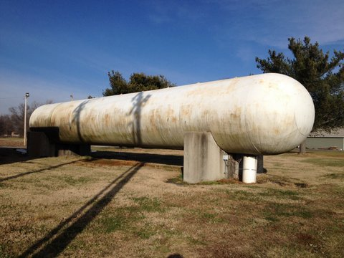

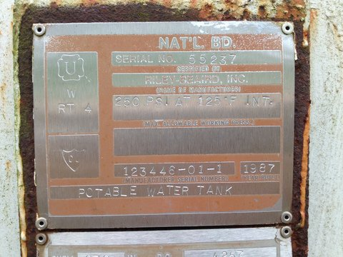

Macintosh HD:Users:jessicaveldman:Desktop:RILEY BEAIRD NB 55237.pdf